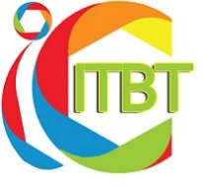 | International Conference on Innovative Trends in  Business & Technology (iCITBT)  17th & 18th December, 2020  http://www.iksp.org

[Title, Font 16] Sample Manuscript Showing Style and Formatting Guidelines

First Name, LAST NAME of Author A,^{a*} First Name, LAST NAME of Author B,^{b} First Name, LAST NAME of Author C^{c}
ªAffiliation ^{b}Affiliation ^{c}Affiliation
*name@corresponding.author

Abstract – This template shows the appearance of a manuscript for the Pertanika Journal of Scholarly Research Reviews (PJSRR). Begin the abstract after one blank line below the email of the corresponding author. The abstract should be in a single paragraph containing no more than 250 words. Immediately after the abstract is a list of up to six keywords. Manuscripts must be submitted in MS Word format (.doc or .docx) to srrjeditor@upm.edu.my, with ‘Manuscript Submission’ written in the subject field. At present, submissions to PJSRR are open to UPM postgraduate students only. Review articles must pertain to any field of study offered in UPM, and should also include the name(s), faculty affiliation(s), and email(s) of each author, with one designated corresponding author.

